1. Introduction (Times New Roman, Bold, 10pt)
Kazuo Igaku¹⁾ and Mitsuko Butsuri²⁾ (Times New Roman, 10pt)
1) Institute of Medical Physics, 2) Health Peace Univ., Medical Physics (Times New Roman, 10pt)
Blank space

Title of proceedings (Times New Roman, Bold, 12pt) You CAN NOT change the title from the original one you submitted with.

This document is a template for Microsoft Word. Please be sure to use the template Word file without changing the format. You can download the template file from the web page linked to the JSMP home page. (Main Text: Times New Roman, 10pt)

2. Materials and Methods (Times New Roman, Bold, 10pt)
Please do not delete the “Blank space” at the left of the title. (Main text: Times New Roman, 10pt)

3. Results and Discussion (Times New Roman, Bold, 10pt)
The font size is listed in Table 1. (Main text: Times New Roman, 10pt)

Corresponding author: Kazuo Igaku [Yamabukicho 358-5, Shinjuku-ku, Tokyo, 1620-0801, Japan]・jsmp@imp.ac.jp (Times New Roman, 8pt)

4. Conclusion (Times New Roman, Bold, 10pt)
Please do not change the margins. (Main text: Times New Roman, 10pt)

Acknowledgements if required: (Times New Roman, Bold, 8pt)
(Main text: Times New Roman, 8pt)
Table 1 This is an example table. The authors must use these fonts.
Item | Fonts
Title | Times New Roman, Bold, 12pt
Authors | Times New Roman, 10pt
Headlines | Times New Roman, Bold, 10pt
Main text | Times New Roman, 10pt
Reference headline | Times New Roman, Bold, 8pt
Reference text | Times New Roman, 8pt
Fig. and Table captions | Times New Roman, 8pt
Affiliation, corresponding author | Times New Roman, 8pt
Acknowledgements | Times New Roman, 8pt

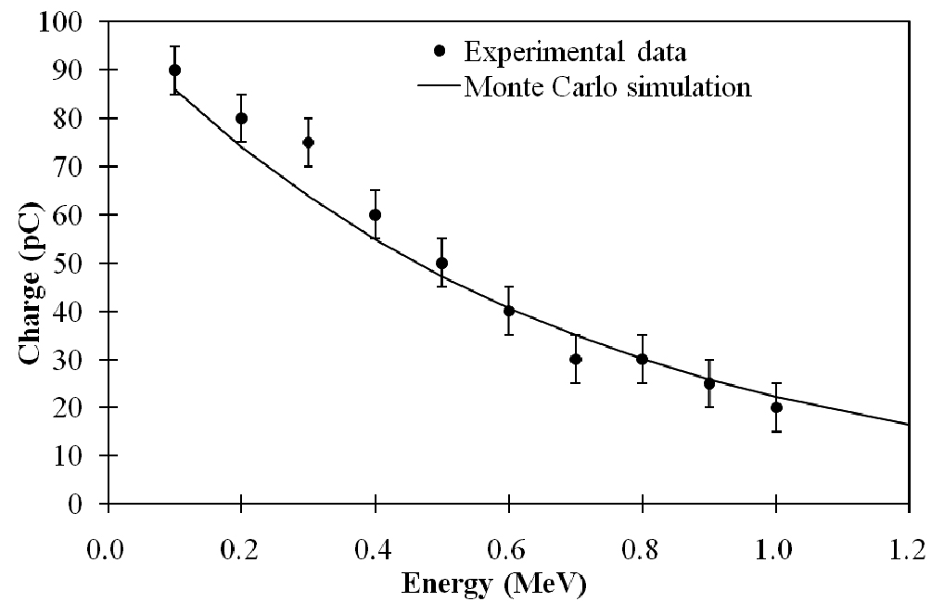
Fig. 1 This is an example figure. The labels, numbers, legends, symbols, lines and everything must be clear when printed.

References (Times New Roman, Bold, 8pt)
1) Krämer M, Jäkel O, Haberer T, et al.: Treatment planning for heavy-ion radiotherapy -physical beam model and dose optimization, Phys. Med. Biol. 45, 3299-3317, 2000.
2) Muehllehner G: Scintillation camera collimators.: Nucelman S, Patton DD eds, Imaging for Medicine, 77-87, 1980, Plenum Press, New York & London.

